<Monopoly Game>

Use-Case Realization Document

# Introduction

## Purpose

This document describes the use-case realization comprehensively, in terms of how each use-case is design with sequence diagram and class diagram.

## Scope

This document is for the developing Monopoly Game which will run on android platform. It provides overall realization for each use-case in Monopoly Game.

## Definitions, acronyms, abbreviations

|  |  |
| --- | --- |
| Acronyms and Abbreviations | Definition |
| System | Monopoly Game System |
| Observer | User that plays Monopoly Game |

## References

SRS.

# Use-Case Realization Detail

## Start Game

sequence diagram:

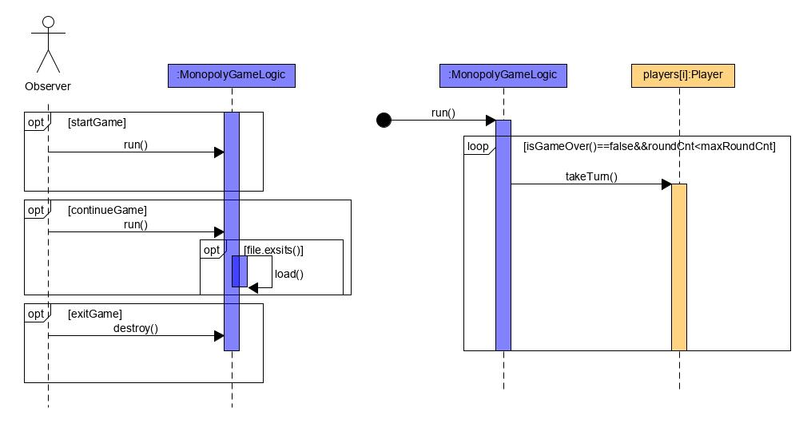

concept class diagram:

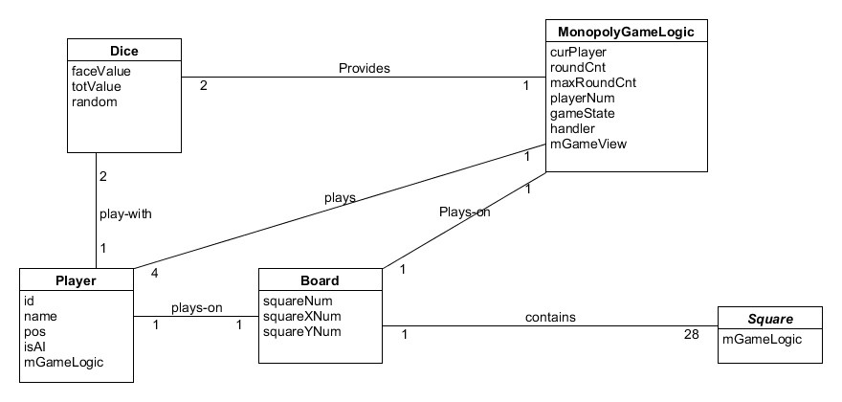

design class diagram:

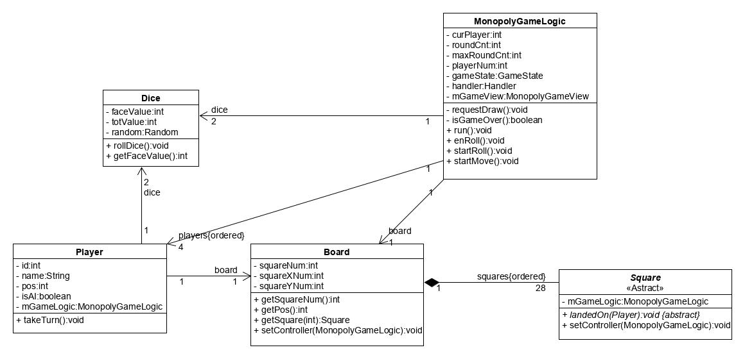

## Move

sequence diagram:

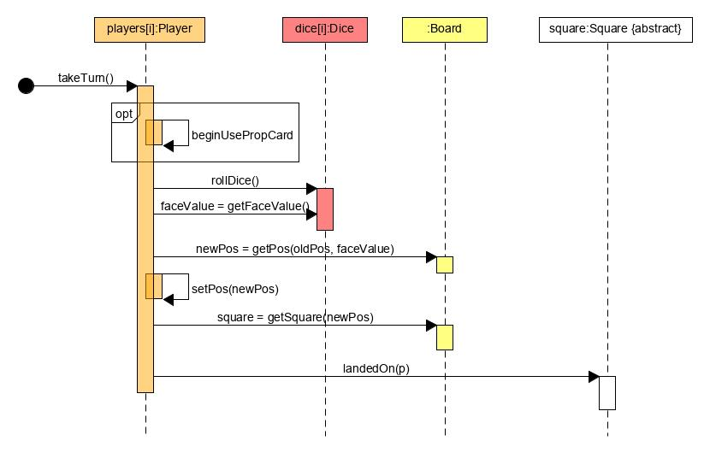

concept class diagram:

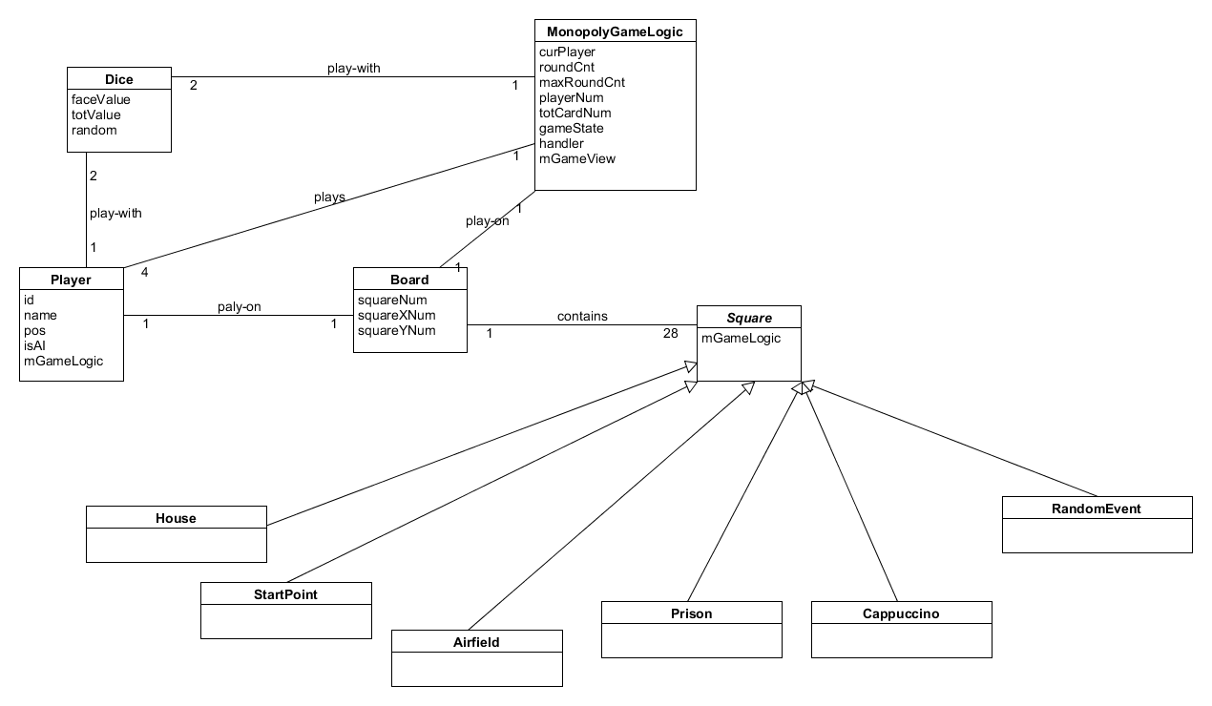

design class diagram:

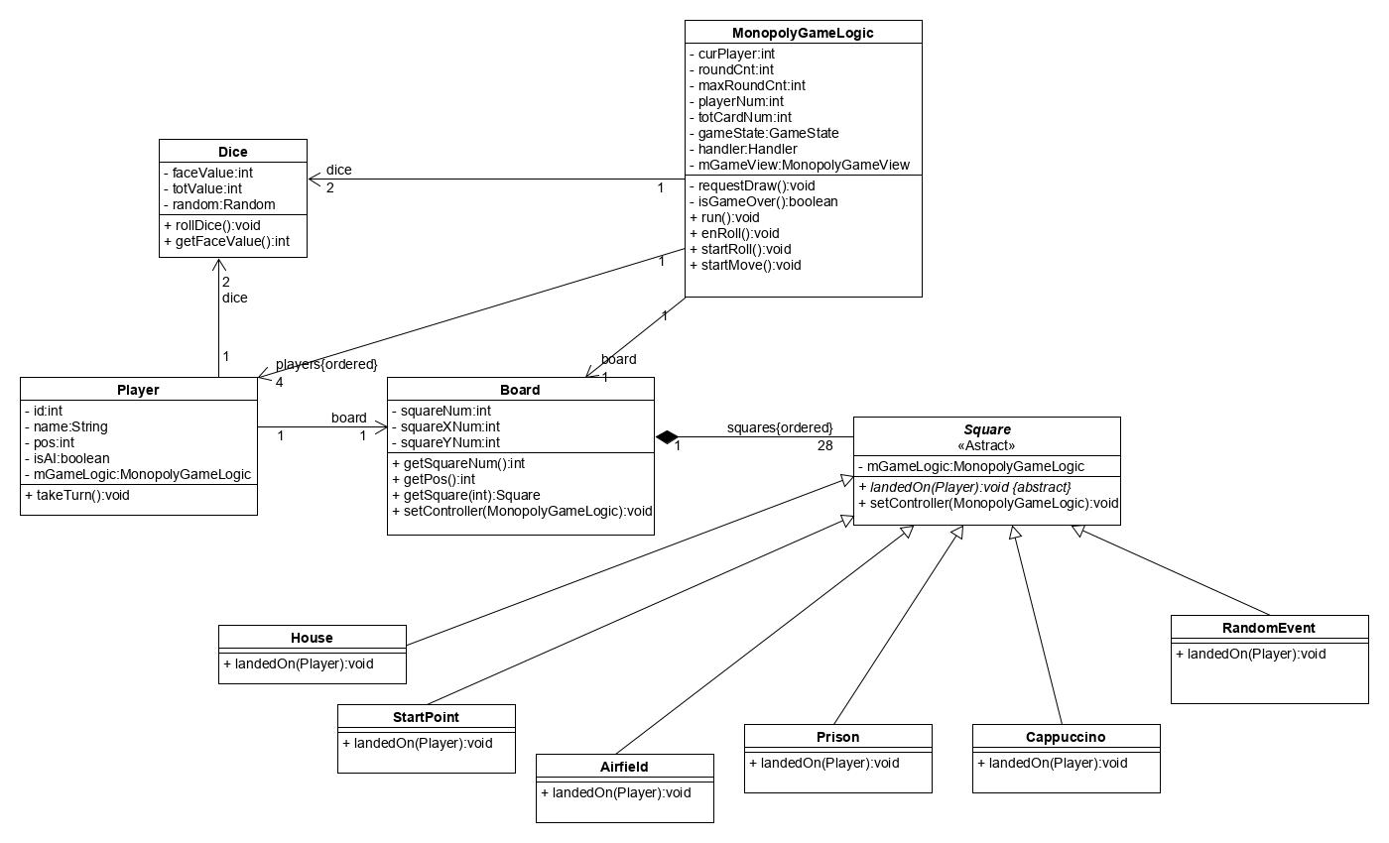

## Use Propcard

sequence diagram:

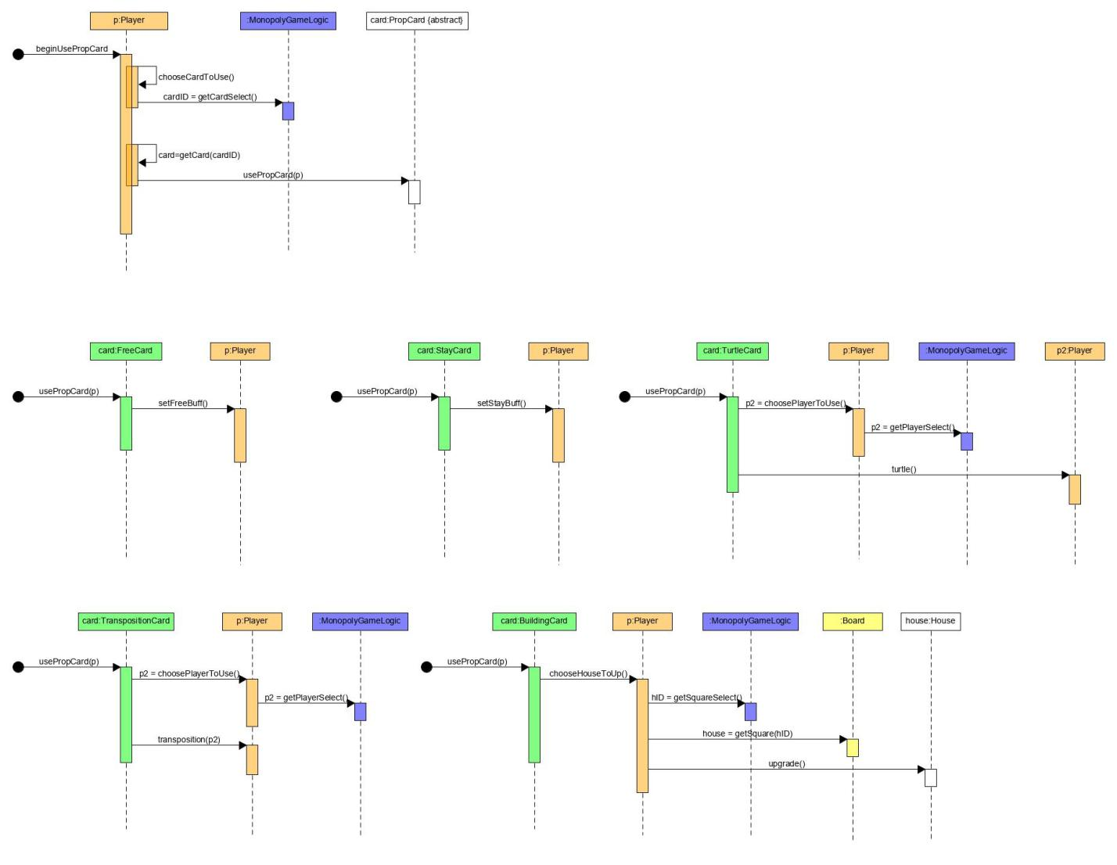

concept class diagram:

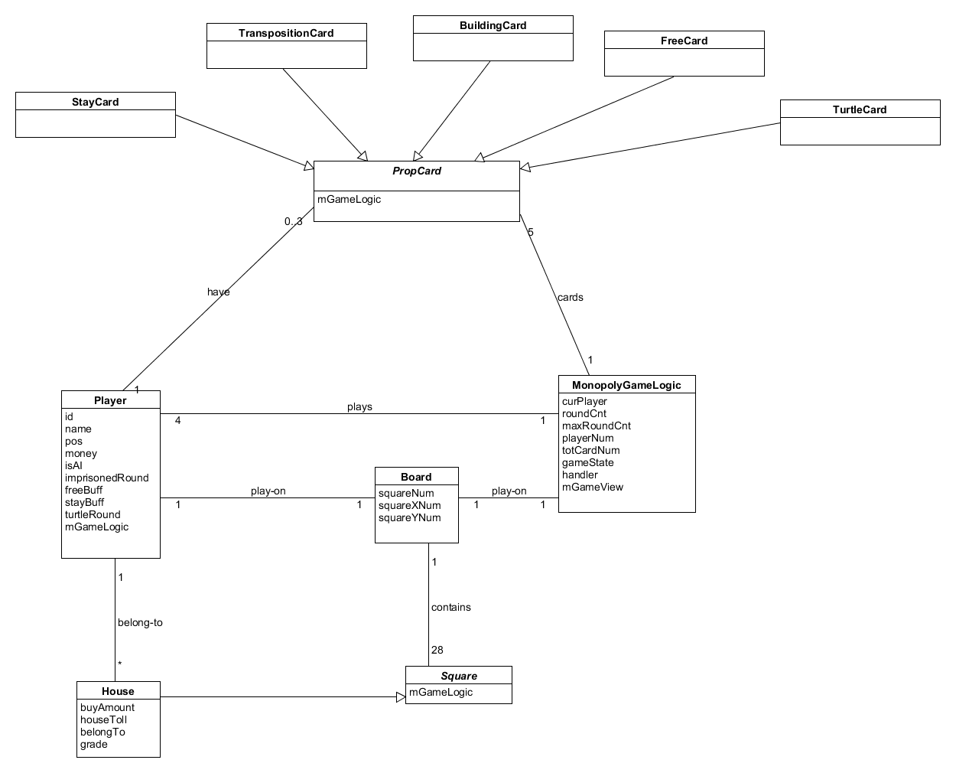

design class diagram:

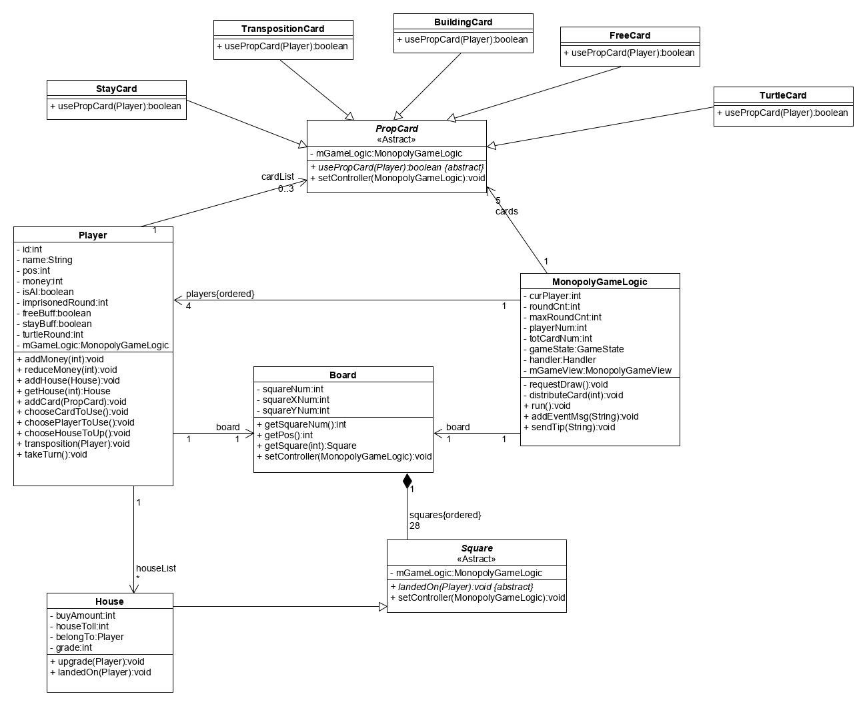

## Trigger event in a square

sequence diagram:

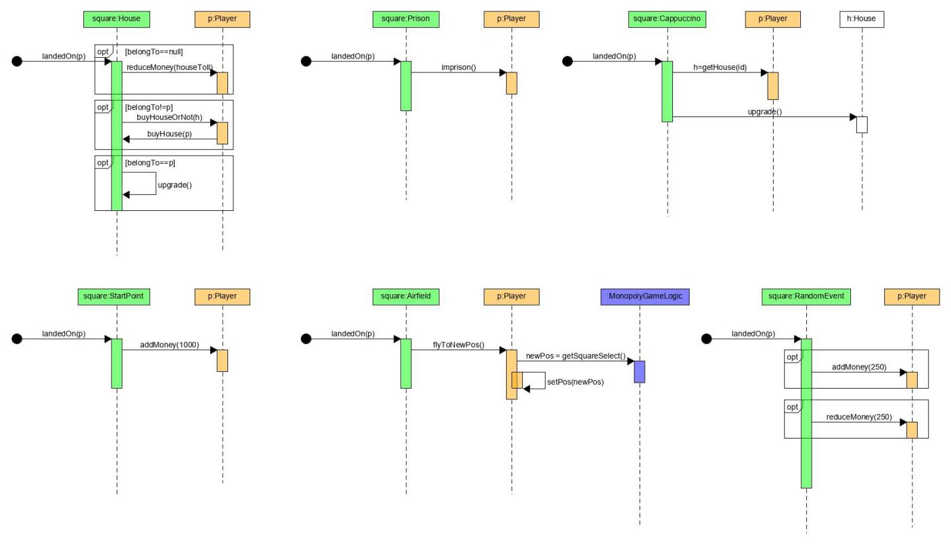

concept class diagram:

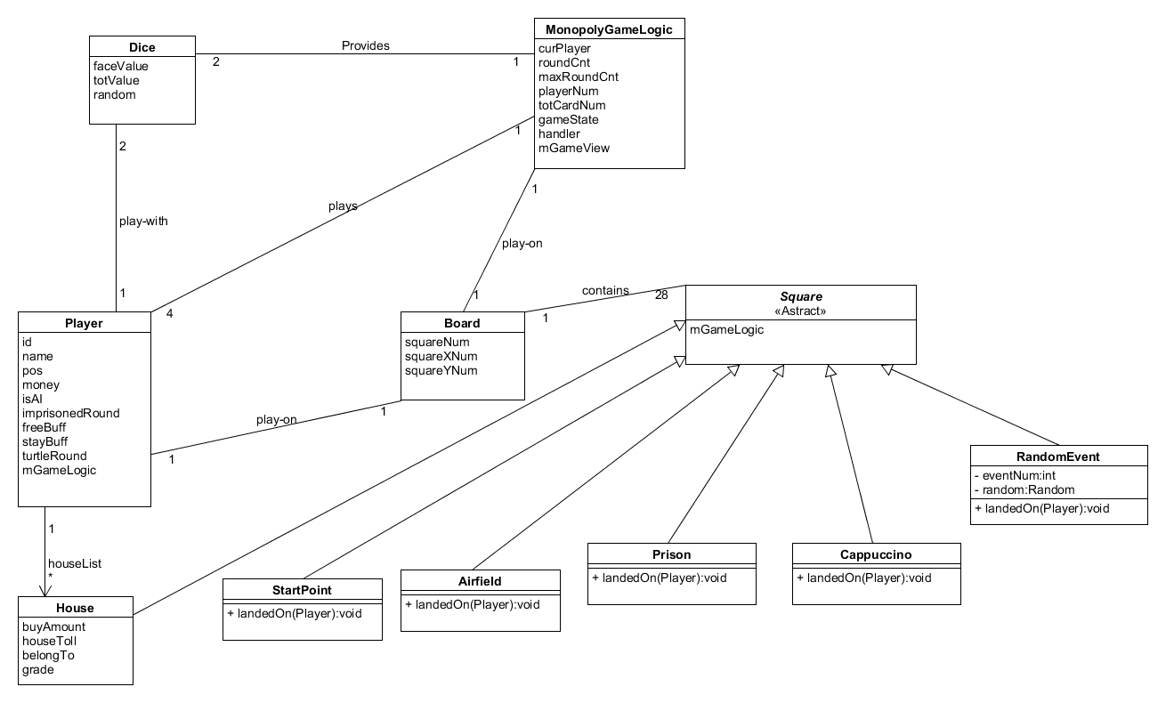

design class diagram:

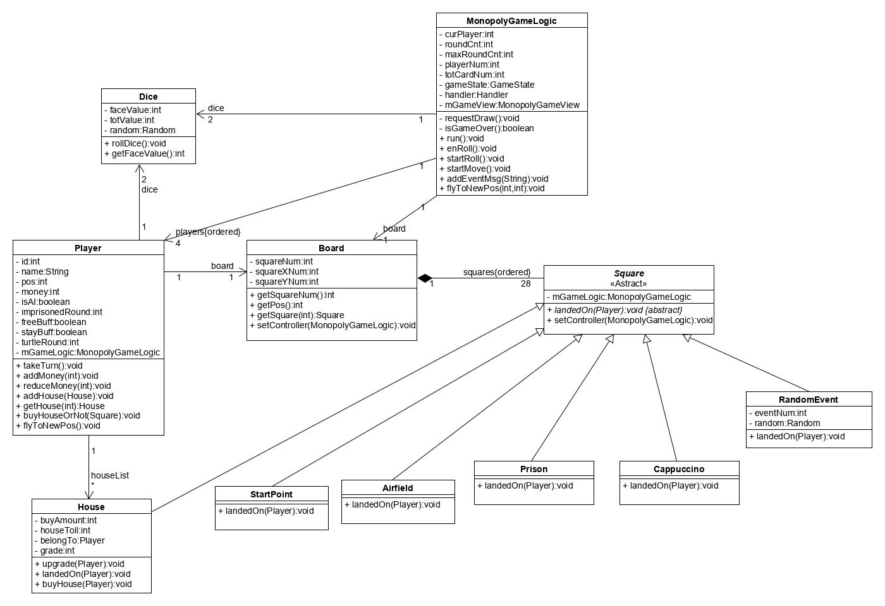

## Save Game

sequence diagram:

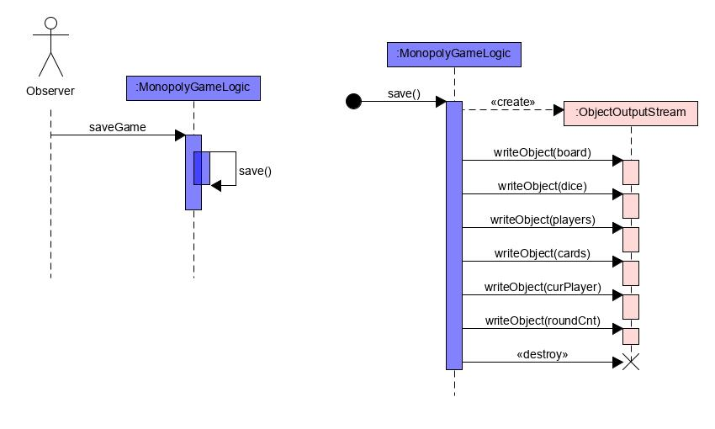

concept class diagram:

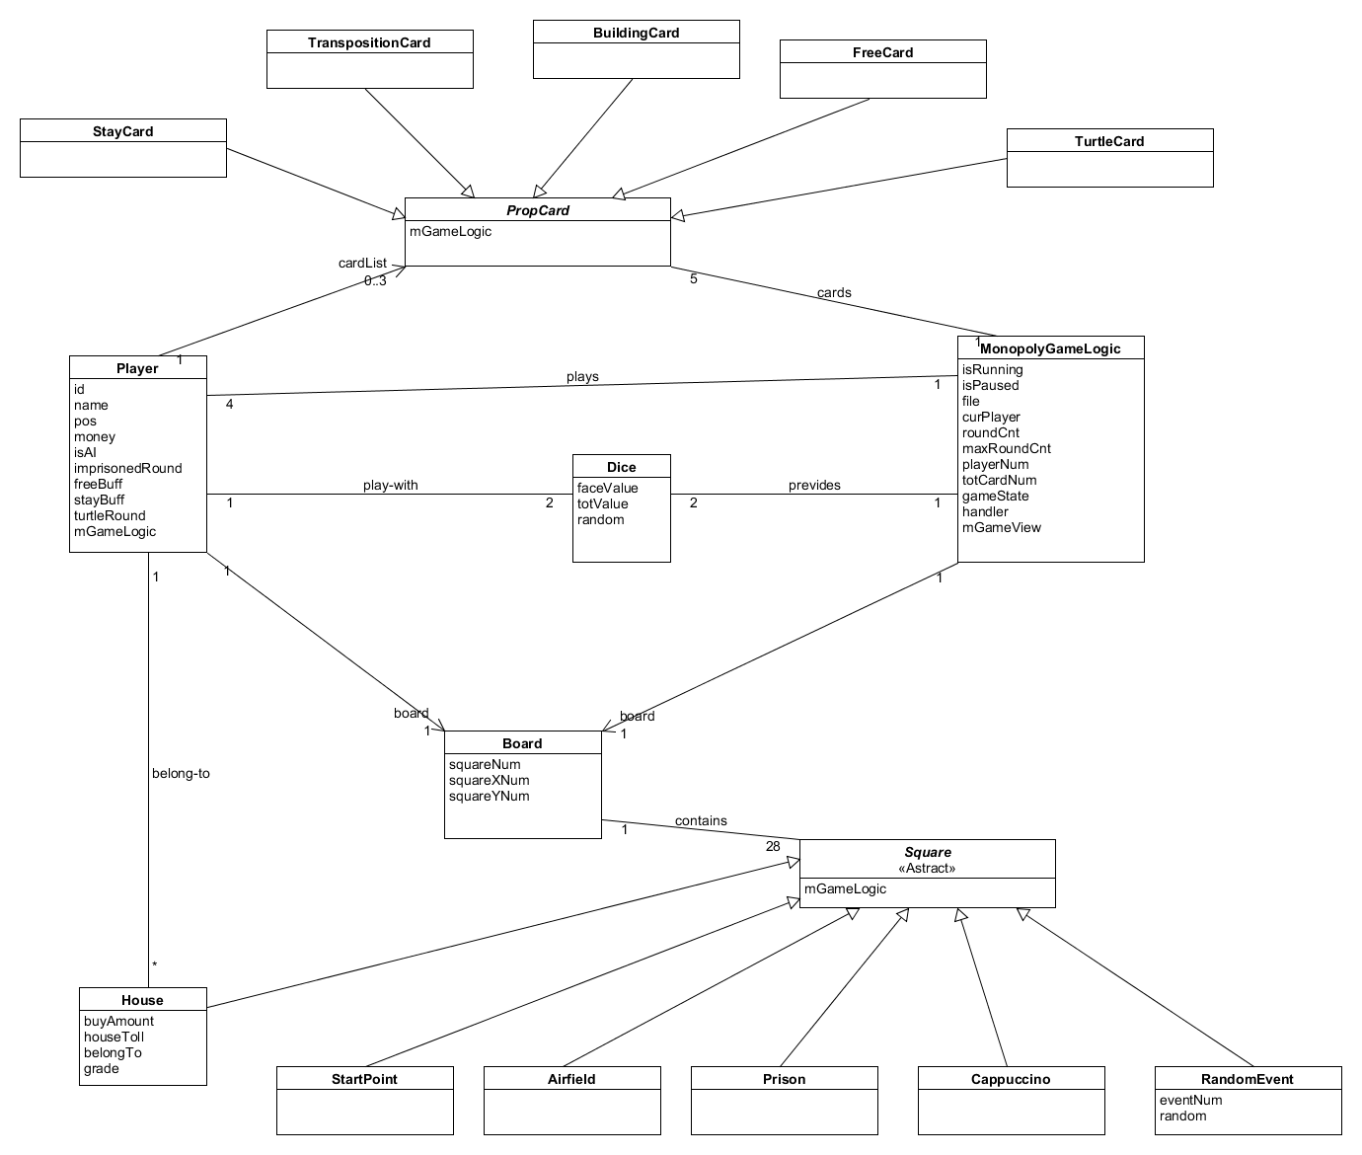

design class diagram:

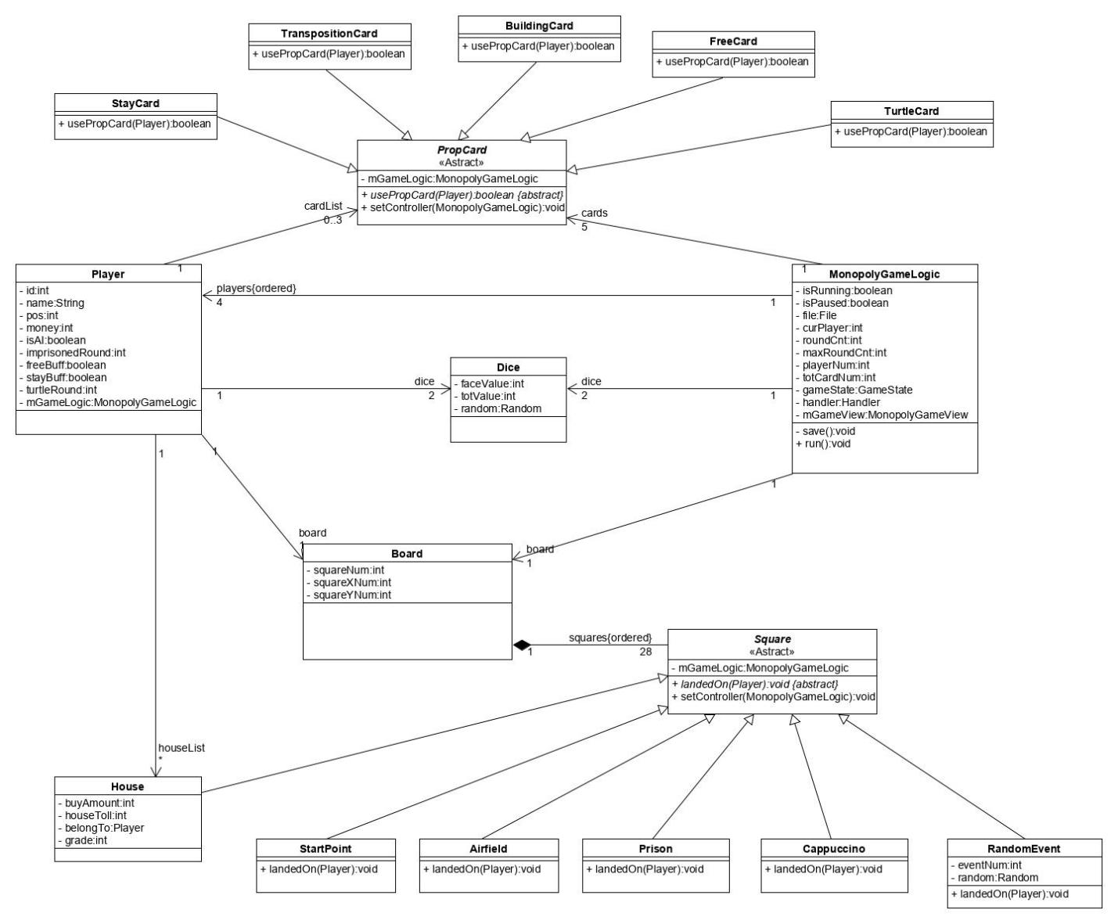

By using ObjectOutputStream in save function, each object in Monopoly Game can be serializable and can be written in file. So each object in the use-case maintains their attributes to record the Monopoly Game state. Actually, every design class is invoked in this use-case.